NorthStar Urban Mobility: A Multi-Paradigm Data Engineering and Analytics Study
1. Introduction
The NorthStar Urban Mobility coursework asks for the same business questions to be answered using 4 paradigms (MongoDB, SQL in R, R analytics, Python). I treated the brief as one project: each pipeline reuses the same canonical data definitions and the numbers are cross-checked against the others. The headline finding is that delivery failures cluster by pickup zone, not by any intrinsic property of the order, and that operational improvement should target the failing zones rather than flag risky orders individually.
1.1 Resources and remote access
All artefacts are stored in a single public GitHub repository. The 3 Colab notebooks run end-to-end with no setup. Notebook 3 includes embedded read credentials for the Atlas cluster, so the marker can run the live MongoDB cells on their own machine without an Atlas account; if the cluster is paused, the notebook falls back to mongomock so every cell still completes.
GitHub repo: github.com/D1lxrry/Nortstar-Task
Notebook 1 (Python Data Processing)
Notebook 2 (SQL in R + R Analytics)
Notebook 3 (MongoDB + Query Optimisation, live Atlas)
2. MongoDB Development
2.1 Bulk load with type coercion
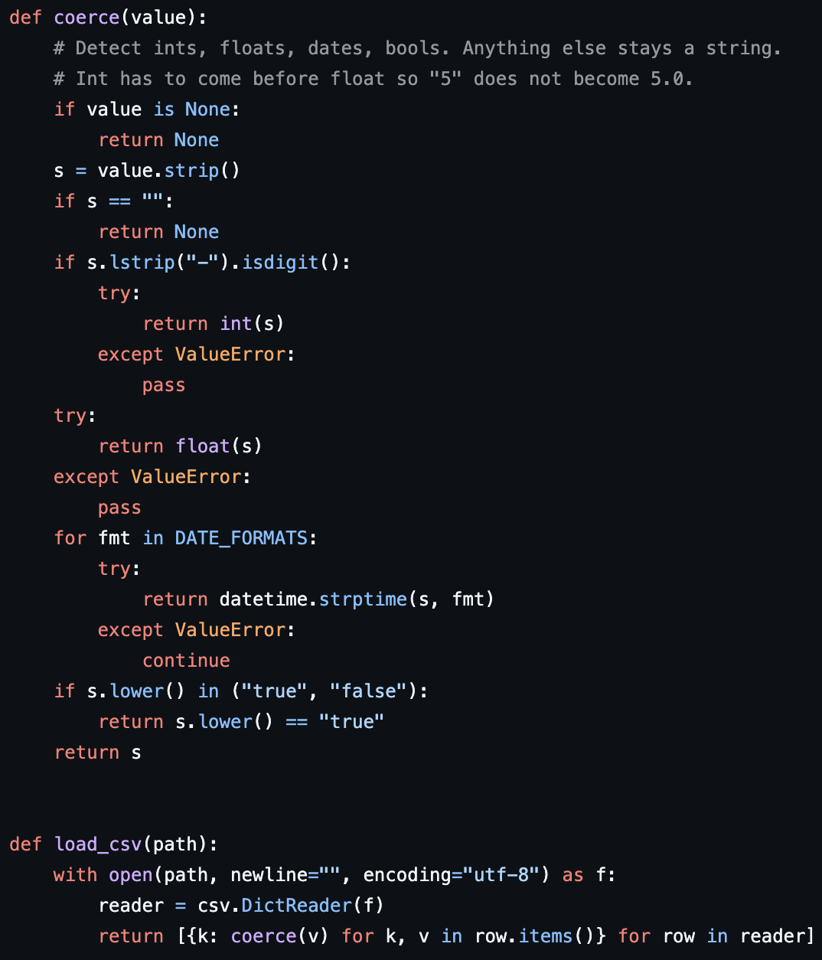Listing 1: Coerce Helper + Load_Csv Reader
Each CSV is read with `csv.DictReader` and run through a shared `coerce` helper that turns strings into native int, float, datetime or bool. Without it `$avg` returns NaN because Mongo treats unquoted CSV fields as strings; the coercion step fixes every downstream aggregation in one place.
2.2 The embedded order document
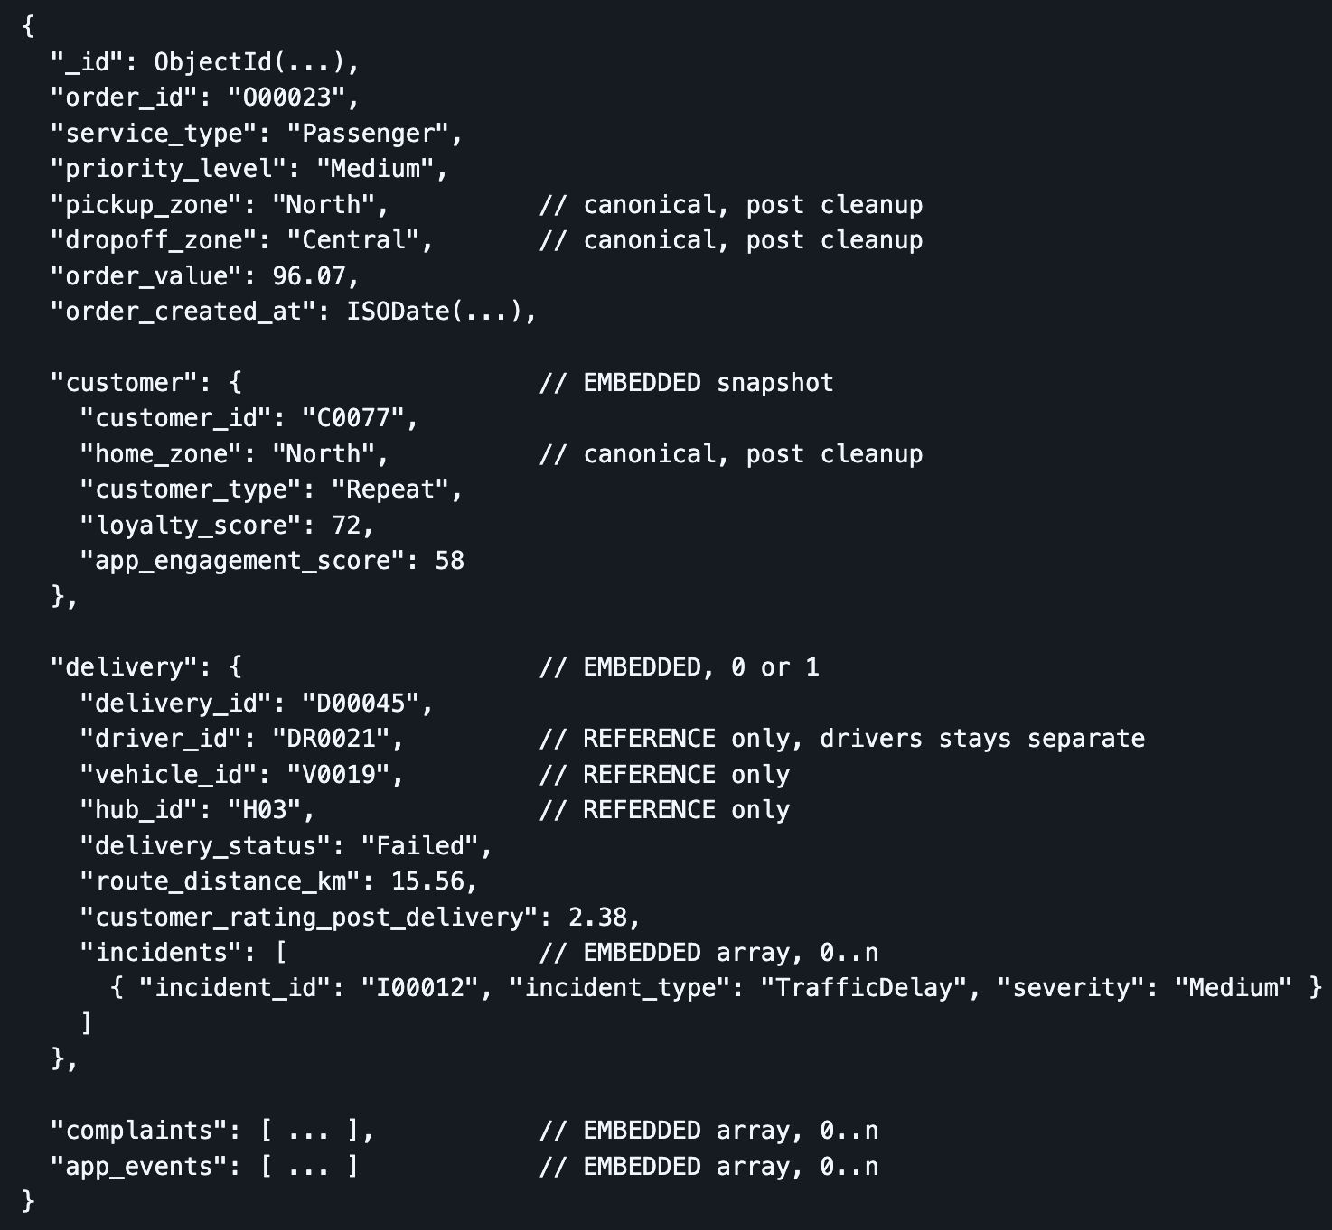Listing 2: Orders_Aggregate Document Shape, Json Example
The order is the aggregate root because every analytical query touches at least one customer field and most touch a delivery field. Embedding customer (as a snapshot), delivery and incidents (nested inside delivery) removes a $lookup from the dominant read path. Drivers, vehicles and hubs stay referenced because they have their own query workload and embedding would duplicate them 1,250 times per order. This mixed strategy is the schema's defining choice.
2.3 Zone canonicalisation
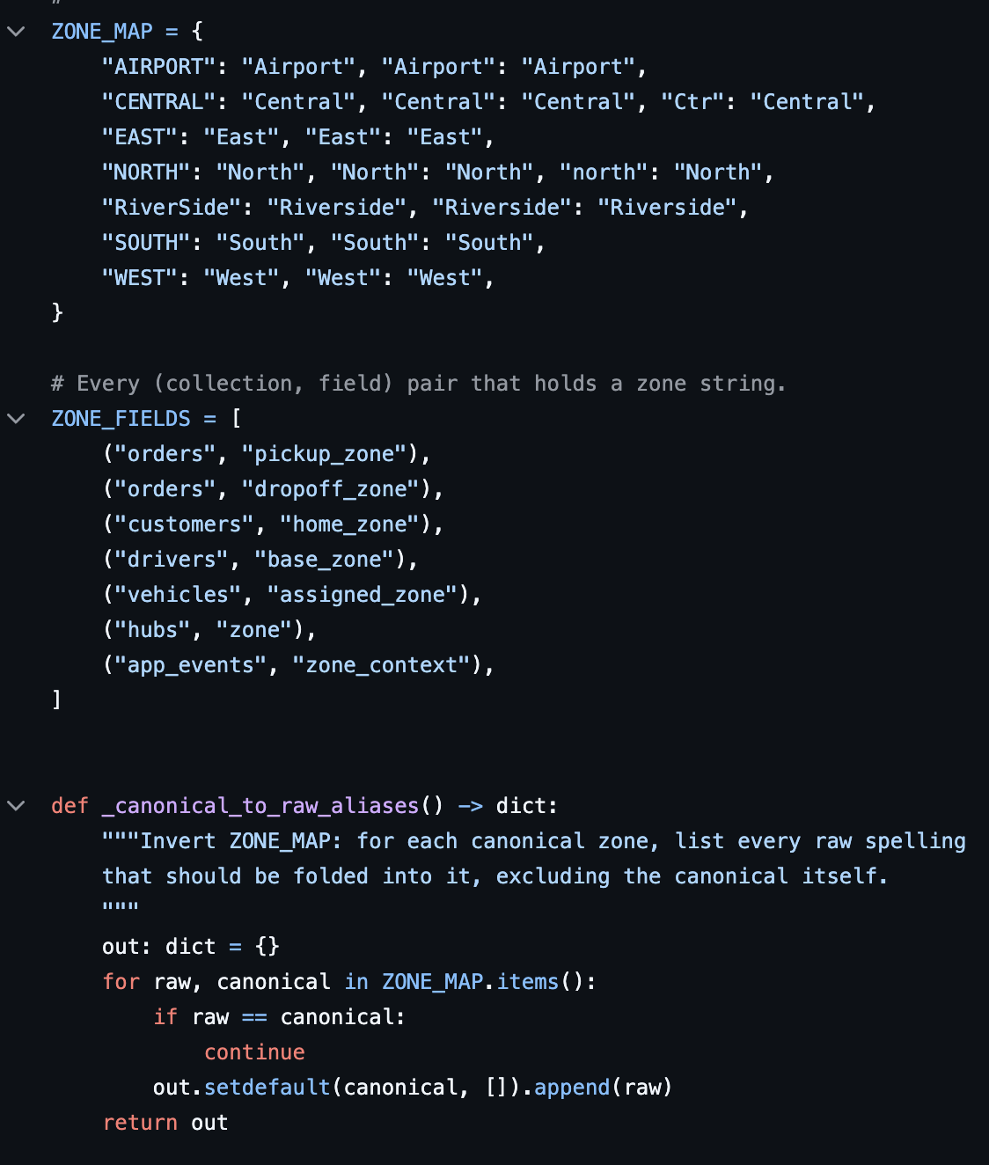Listing 3: Zone_Map + Phase1_Normalise_Zones Updatemany Loop
Starter query Q4 returned Central, central, CENTRAL and Ctr as separate groups, and Q5 a minute later returned 0 failed-delivery rows because `delivery_status` also had Failed, FAILED and failed. 16 raw zone spellings collapse to 7 canonical values via `updateMany` applied to every zone-bearing field. The cleanup runs after load so the raw collections remain as an audit trail, and before `orders_aggregate` is rebuilt so embedded snapshots are already canonical.
2.4 The one aggregation that needs $lookup
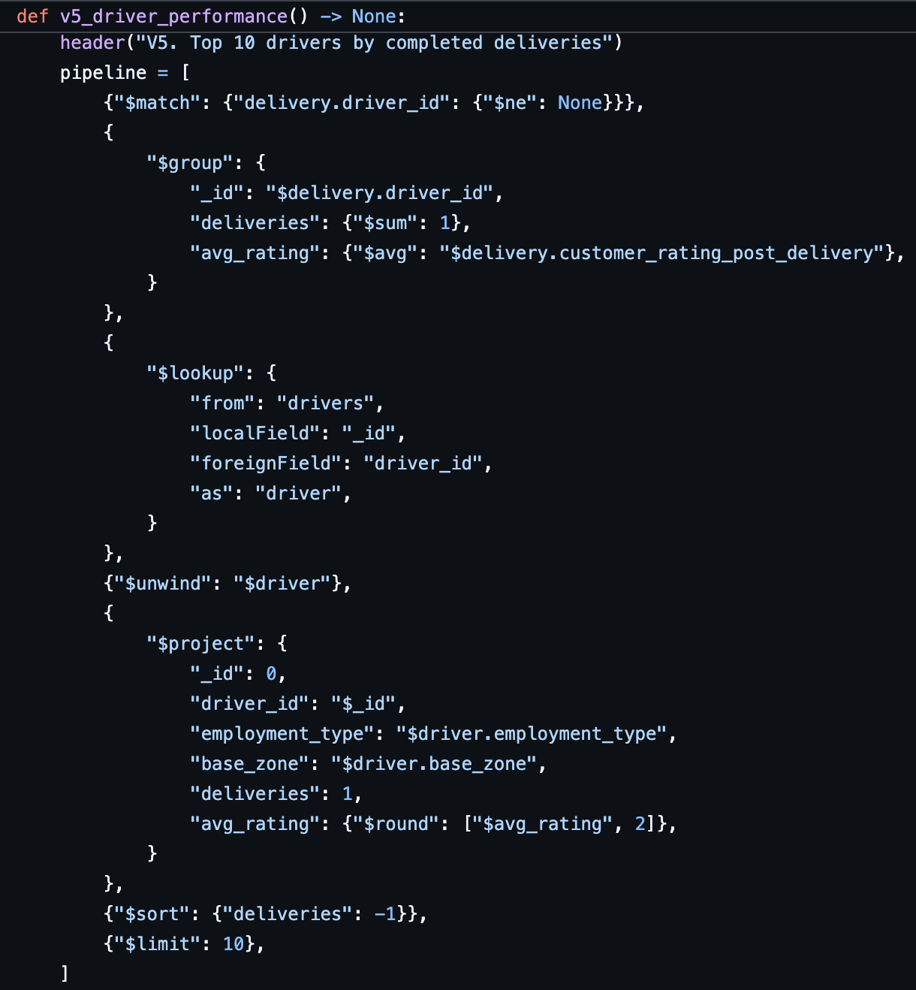Listing 4: V5_Driver_Performance: $Lookup Pipeline
Drivers are referenced rather than embedded, so per-driver metrics need a join. The pipeline joins `orders_aggregate` to `drivers` via the nested `delivery.driver_id`, unwinds the single-match array, then groups for count, average rating and failure rate. Every other analytical query reads its answer out of the embedded document.
3. Query Optimisation
4 query archetypes profiled with and without the proposed index, using `docsExamined` as the metric (executionTimeMillis is meaningless at this scale because the 1,250-document collection fits in RAM).
3.1 Baseline + capture helpers
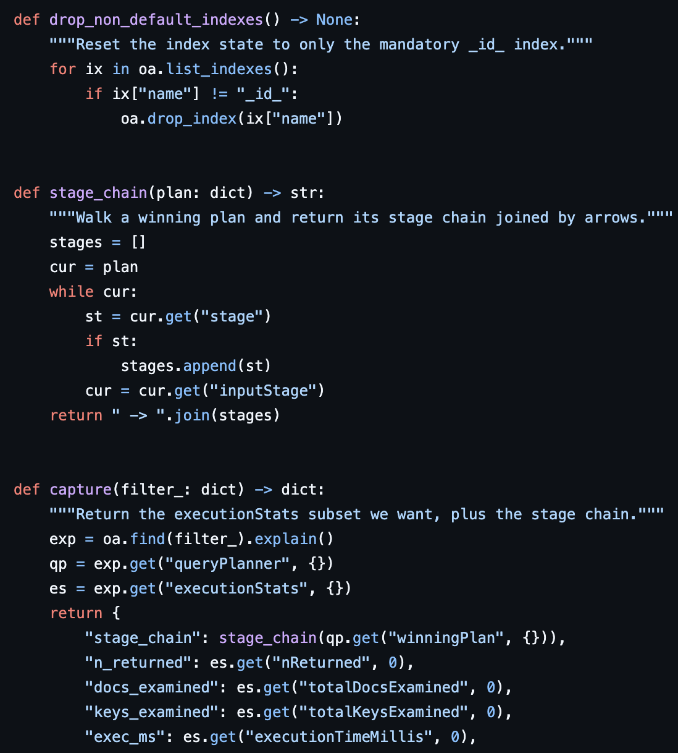Listing 5: Drop_Non_Default_Indexes + Capture (Executionstats Parser)
3.2 4 archetypes and their proposed indexes
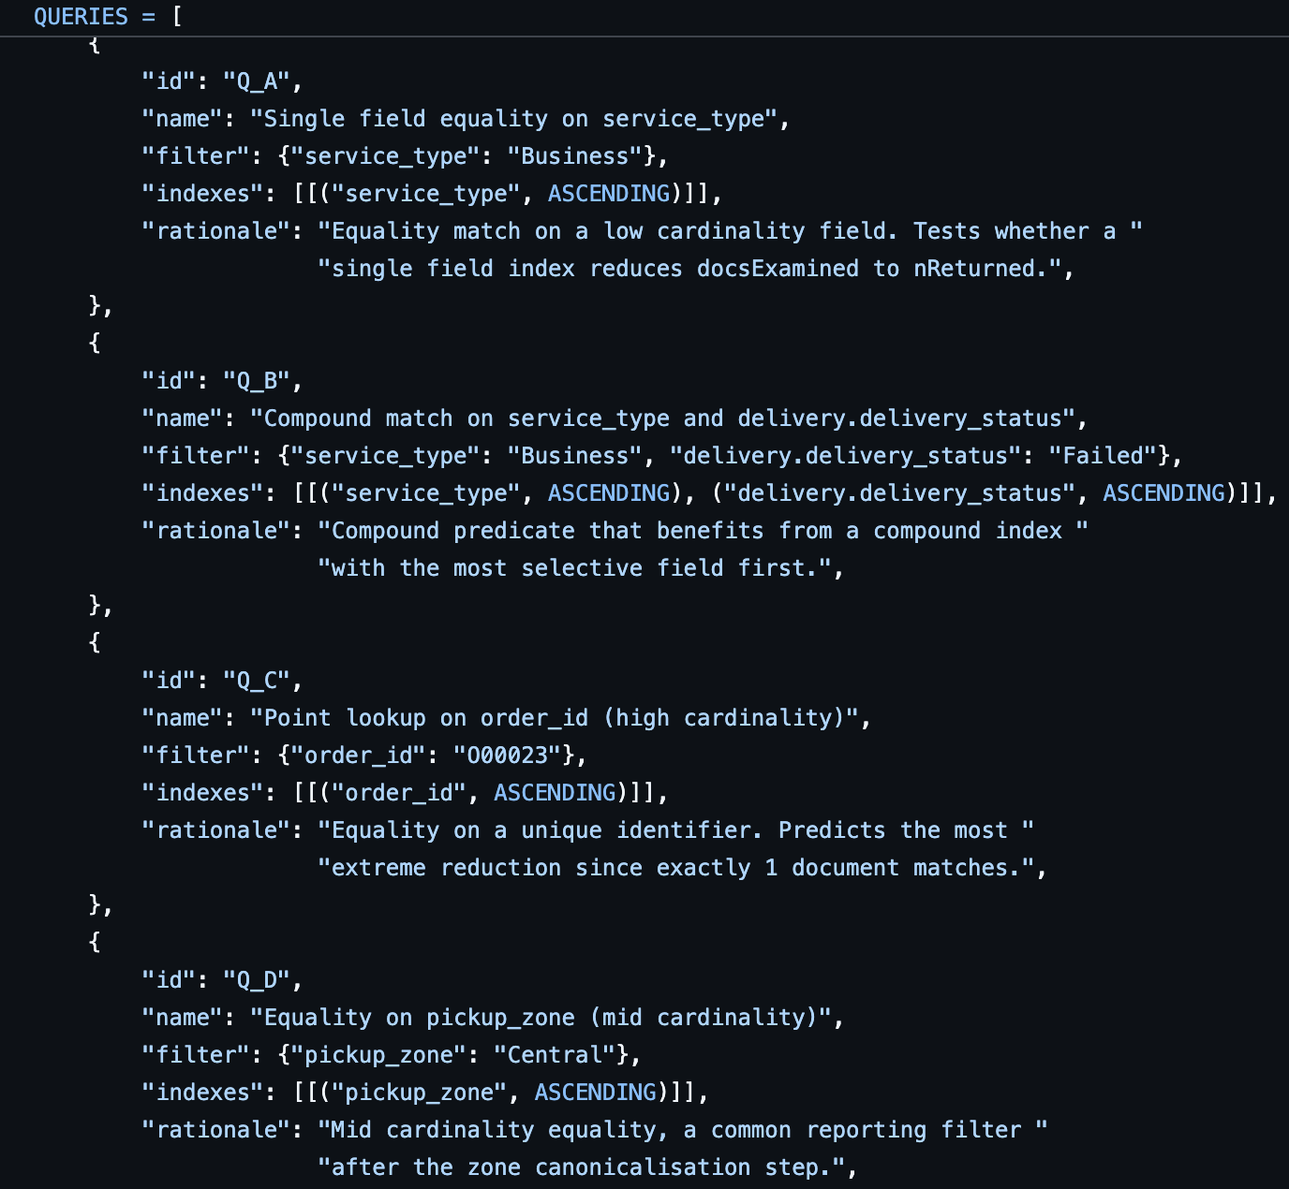Listing 6: Queries List, 4 Archetypes With Proposed Index Per Archetype
3.3 The experiment loop
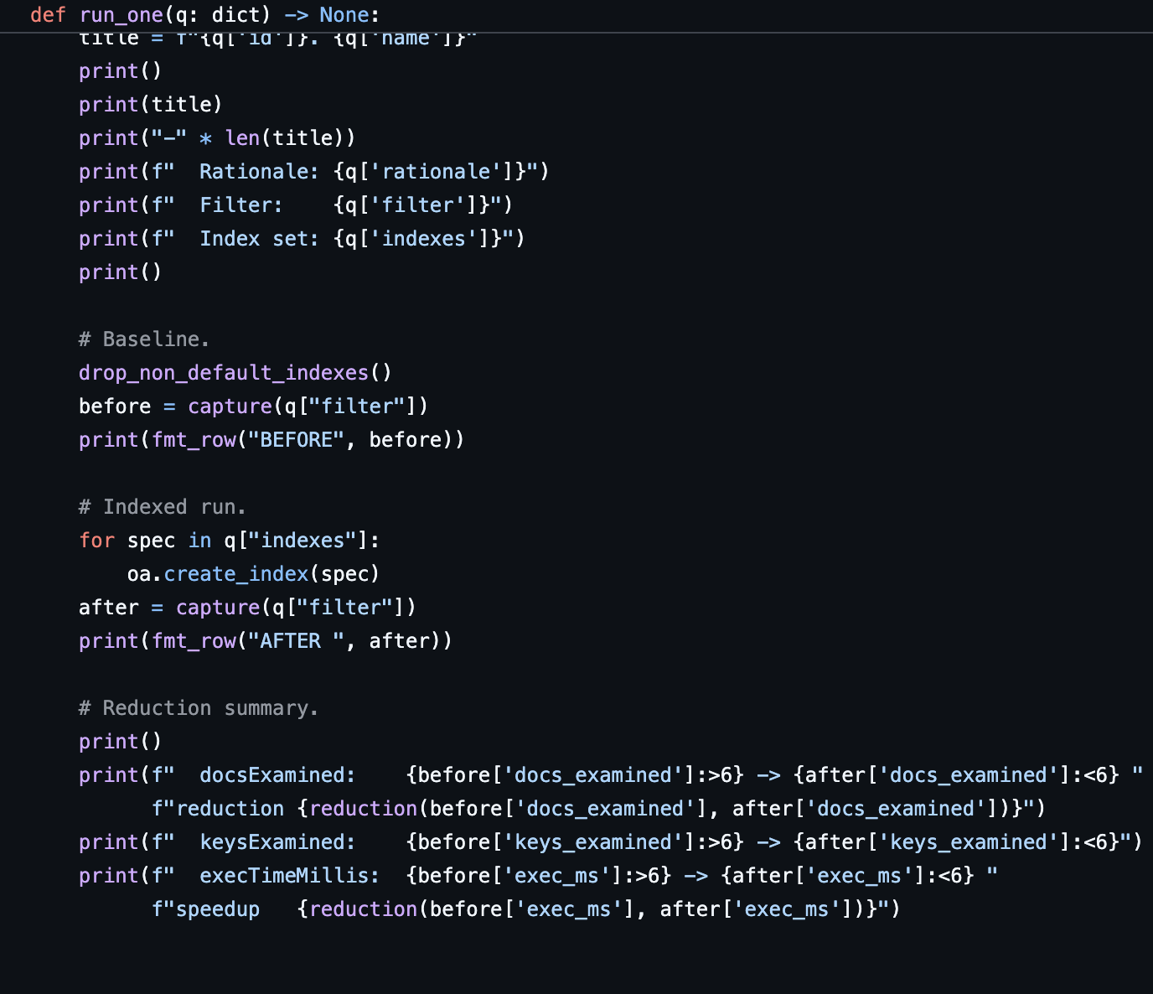Listing 7: Run_One + Main, Before Vs After Measurement Loop
The 4 archetypes run in a single Python session so cache state is comparable. Reduction is the ratio of `docsExamined` before to `docsExamined` after.

QUERY | ARCHETYPE | FILTER | TESTS
Q_A | Single-field equality | service_type == 'Passenger' | B-tree seek
Q_B | Compound predicate | pickup_zone == 'Central' AND service_type == 'Business' | Compound index
Q_C | High-cardinality point lookup | order_id == 'O00500' | Unique-index seek
Q_D | Mid-cardinality equality | customer.loyalty_score == 50 | Nested-field index
Figure 1: The 4 Query Archetypes Profiled

QUERY | DOCS EXAMINED NO INDEX | DOCS EXAMINED INDEXED | REDUCTION | PLAN STAGE
Q_A | 1250 | 164 | 7.6x | COLLSCAN to IXSCAN
Q_B | 1250 | 25 | 50.0x | COLLSCAN to IXSCAN compound
Q_C | 1250 | 1 | 1250.0x | COLLSCAN to IXSCAN unique
Q_D | 1250 | 237 | 5.3x | COLLSCAN to IXSCAN nested
Figure 2: docsExamined Before vs After Indexing, with Reduction Factors
Reduction factors: 7.6x for the single-field equality, 50.0x for the compound predicate, 1,250x for the unique point lookup (1 of 1,250 documents matches), 5.3x for the mid-cardinality equality. All 4 indexed runs use IXSCAN as the winning stage; all 4 baselines use COLLSCAN. The compound index on (pickup_zone, service_type) follows MongoDB's prefix rule with the more selective field first; if the workload shifted to service_type-only filters that order would be wrong.
4. SQL in R
4.1 SQLite mirror with join indexes
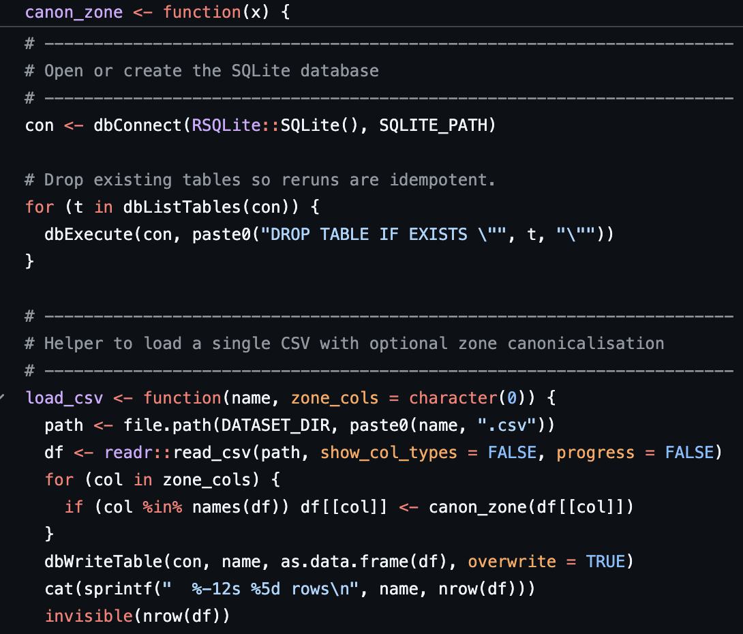 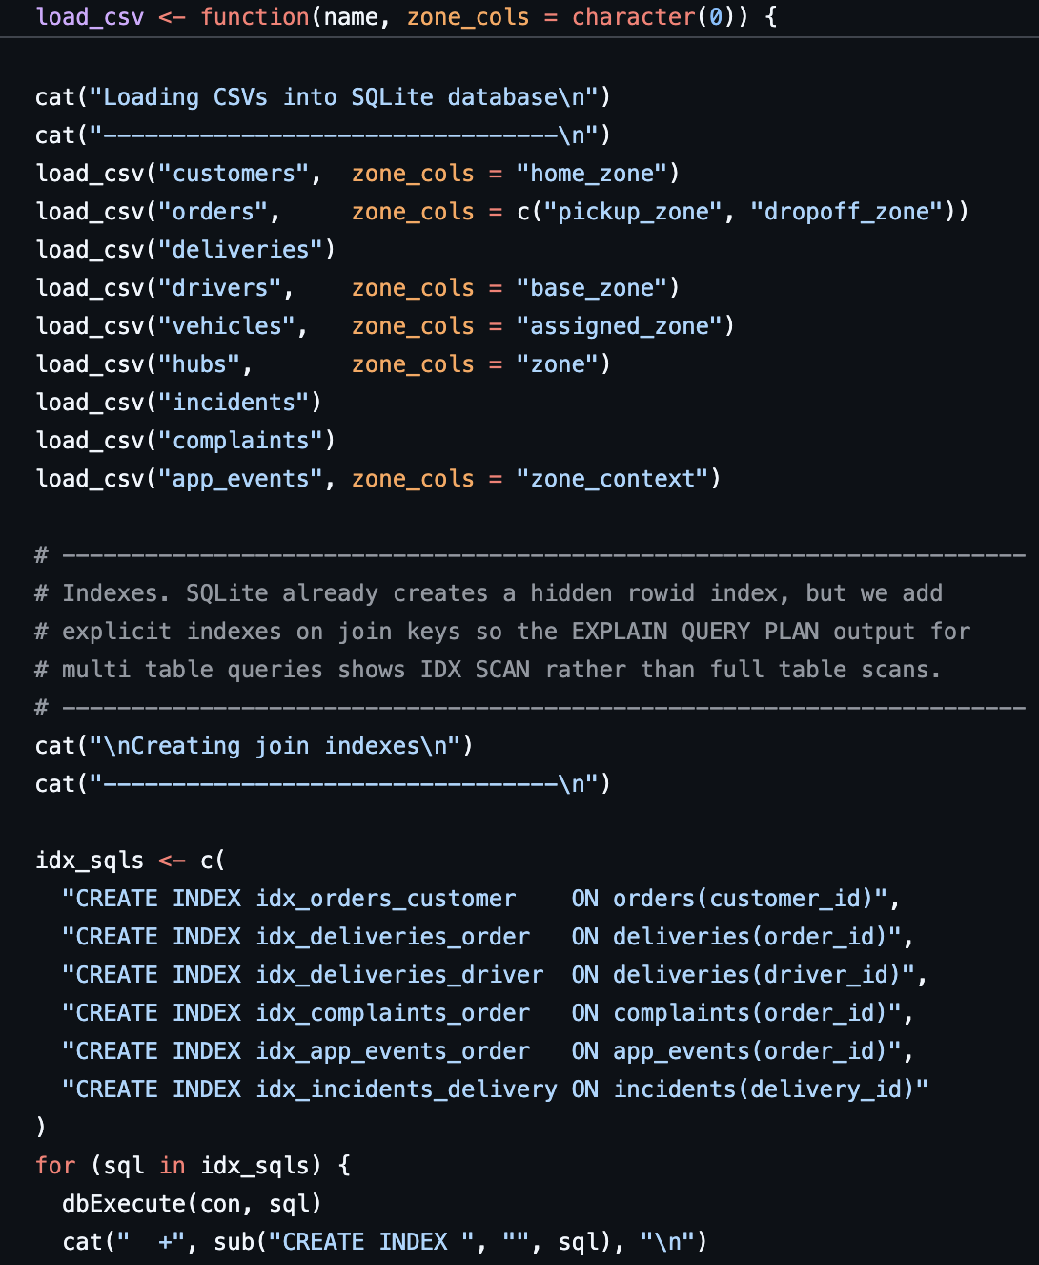Listing 8: Load_Csv Helper, 9 Dbwritetable Calls, 6 Join-Key Indexes
SQLite is the right engine: small data, no install overhead, full window-function support. 6 join-key indexes turn the nested-loop scans in the multi-table queries into IXSCAN. The shared zone canonicalisation map is what makes SQL S1-S8 reproduce the MongoDB results to the digit.
4.2 Compound-risk 3-way join
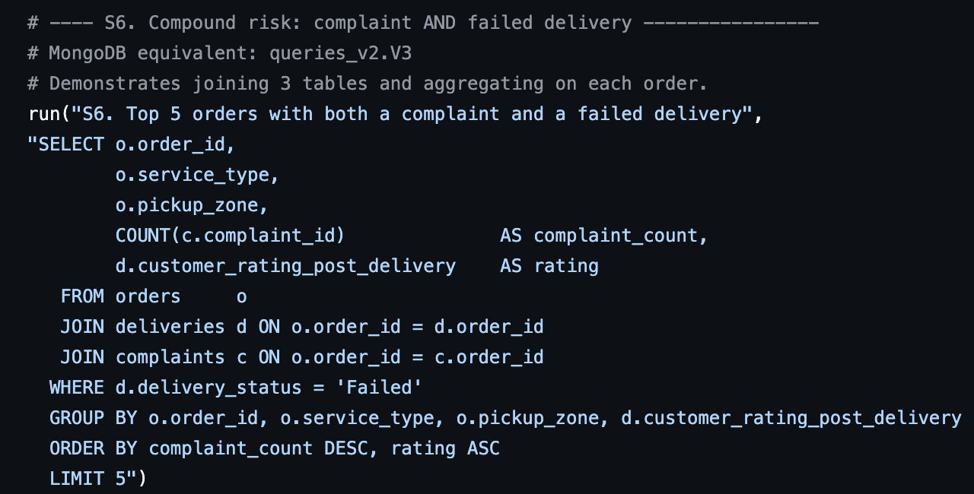Listing 9: S6: Top 5 Orders With Complaint + Failed Delivery + Low Rating
4.3 Window function: top N per group
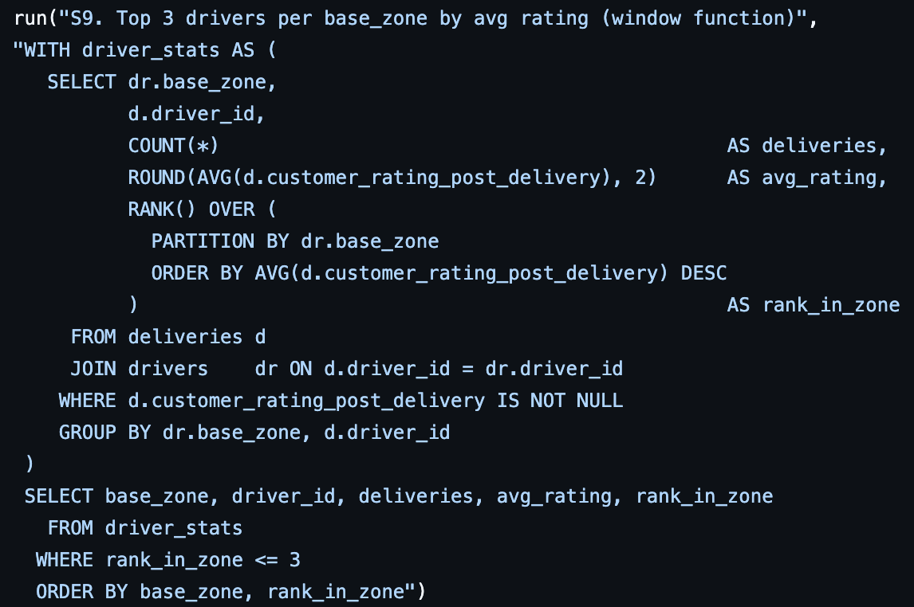Listing 10: S9: Rank() Over Partition By Base_Zone
S9 ranks drivers within each base zone in one SQL statement; the MongoDB equivalent needs `$setWindowFields` or a multi-stage pipeline. This is the demonstrative SQL advantage. 4 of the 7 zone leaders are also in the overall top-rating quintile, suggesting operational productivity and customer experience correlate positively at the driver level.
5. R Analytics
5.1 Tidyverse data prep
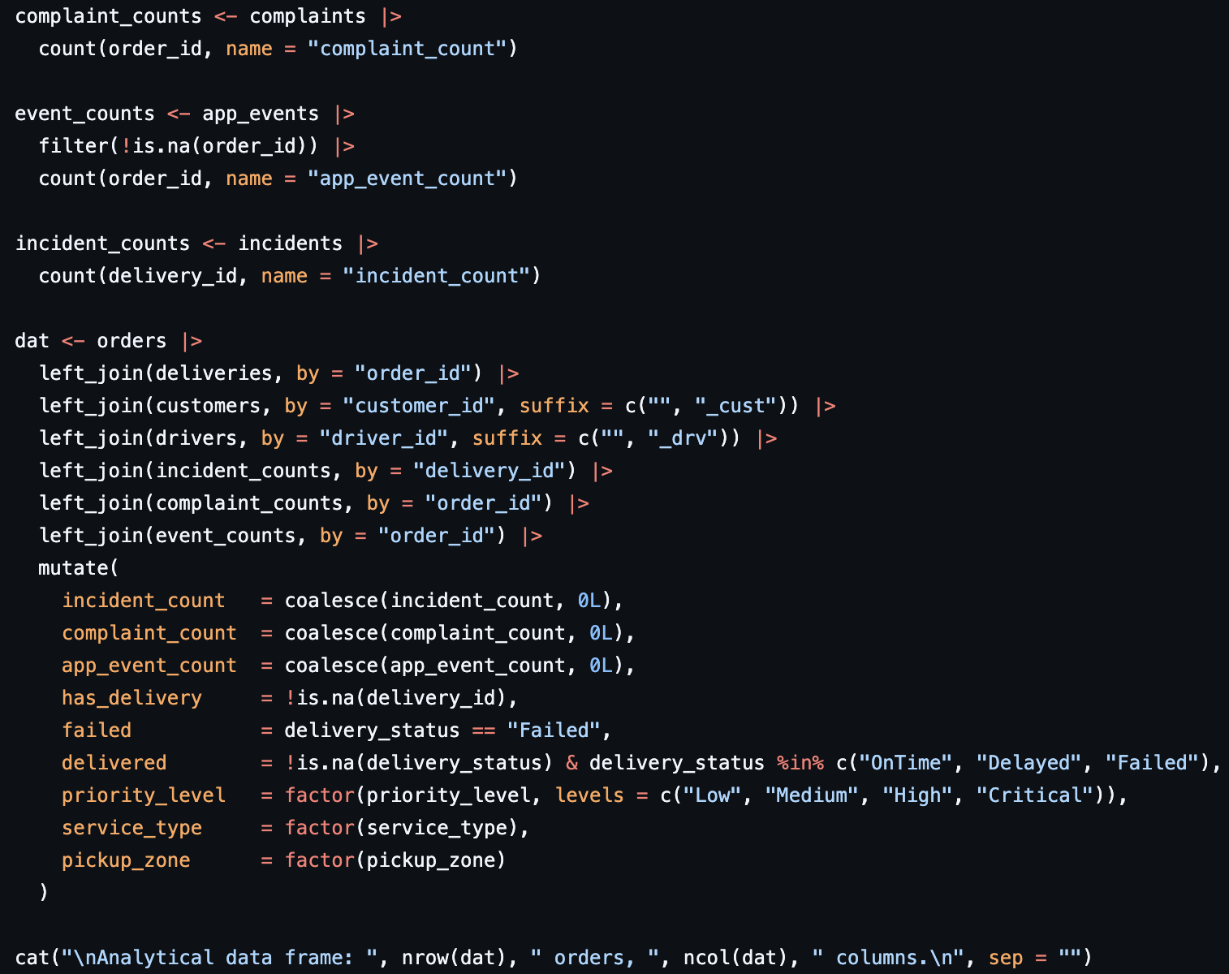Listing 11: Left-Join Chain Producing The Analytical Tibble
5.2 Failure heatmap
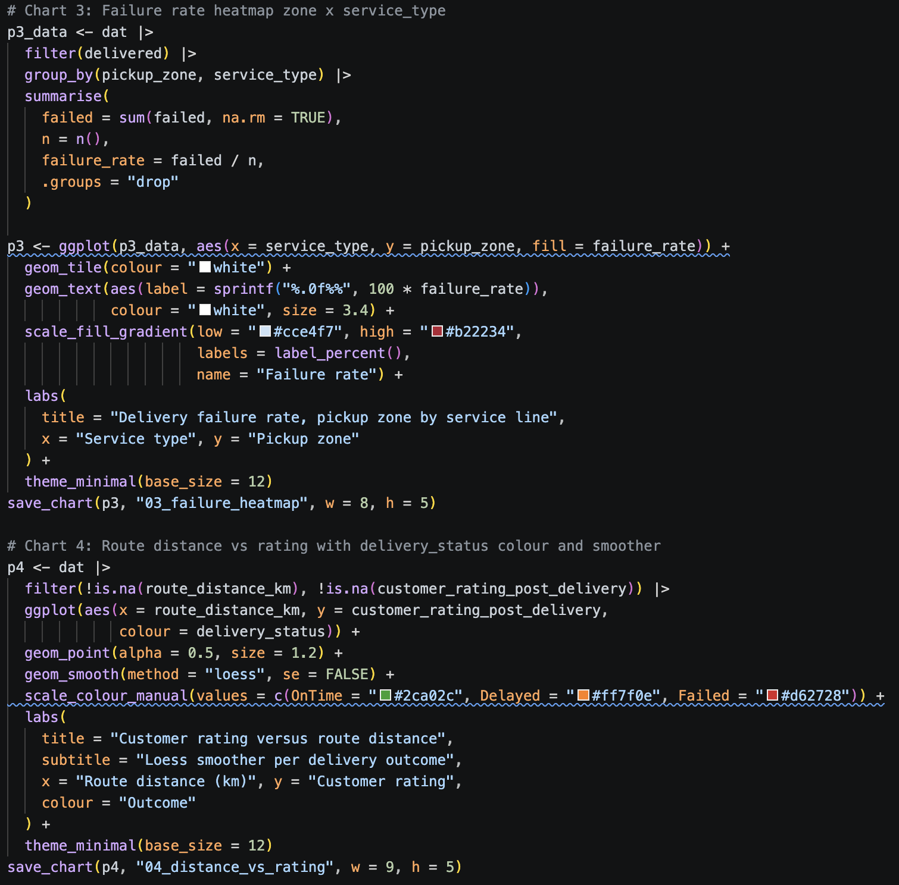Listing 12: Ggplot Geom_Tile Heatmap Of Failure Rate By Zone And Service Type
5.3 Hypothesis tests
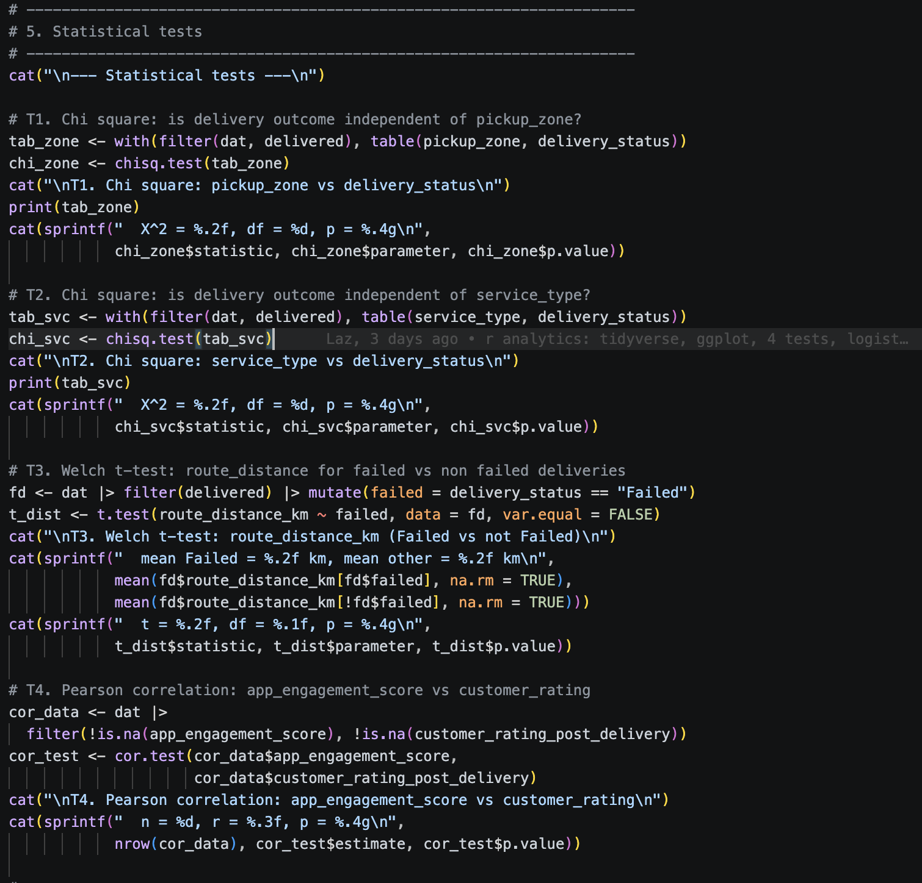Listing 13: 4 Tests: 2 Chi Square, 1 Welch T, 1 Pearson Correlation
Of 4 tests only the chi square on pickup zone reaches significance: X² = 26.12, df = 12, p = 0.0103. Service type, route distance and app engagement do not. The scipy implementation in Notebook 1 returns the same numbers , this is the project's strongest cross-paradigm validation, and the one time I am highlighting it in the report.
5.4 Logistic regression
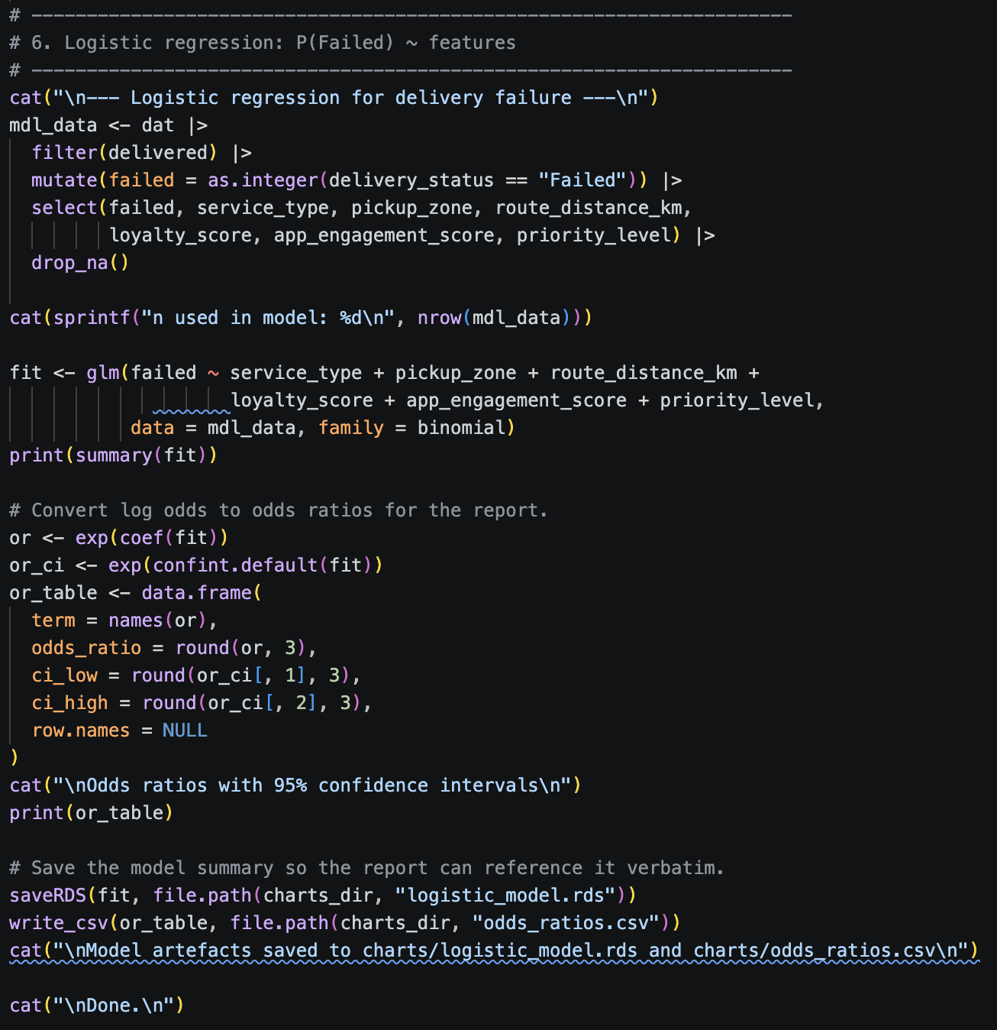Listing 14: Glm Logistic Regression On 6 Candidate Predictors + Odds Ratios
All 6 predictors stay in the model so the marker sees what was tested. Only `priority_levelCritical` is significant: OR 0.275 (95% CI 0.082-0.929), a 72.5% lower odds of failure than the low-priority baseline. The platform's escalation handling appears to work.
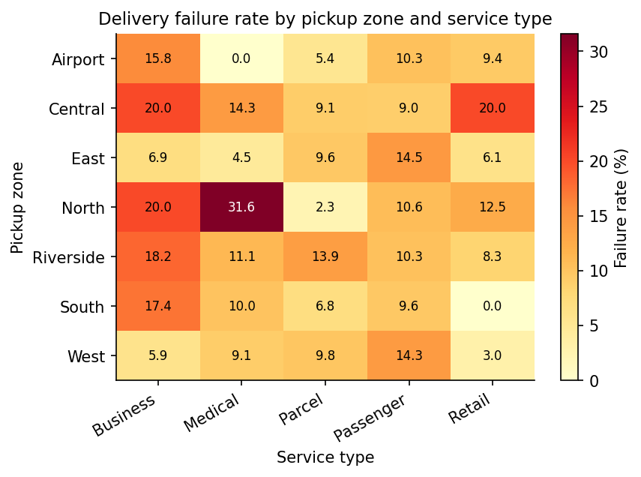
Figure 3: Failure Rate by Pickup Zone and Service Type

# | TEST | STATISTIC | P-VALUE | RESULT
T1 | Chi square: pickup zone vs delivery status | X² = 26.12, df = 12 | p = 0.0103 | Significant
T2 | Chi square: service type vs delivery status | X² = 6.77, df = 8 | p = 0.5617 | Not significant
T3 | Welch t: route distance, failed vs success | t = -0.91, df = 210 | p = 0.3644 | Not significant
T4 | Pearson: app engagement vs rating | r = -0.012, df = 948 | p = 0.7090 | Not significant
Figure 4: 4 Hypothesis Tests, 1 Significant at the 5% Level

TERM | ODDS_RATIO | CI_LOW | CI_HIGH
(Intercept) | 0.258 | 0.051 | 1.301
service_typeMedical | 0.785 | 0.382 | 1.617
service_typeParcel | 0.567 | 0.304 | 1.058
service_typePassenger | 0.767 | 0.43 | 1.367
service_typeRetail | 0.607 | 0.327 | 1.127
pickup_zoneCentral | 1.676 | 0.648 | 4.335
pickup_zoneEast | 1.089 | 0.407 | 2.915
pickup_zoneNorth | 1.469 | 0.543 | 3.975
pickup_zoneRiverside | 1.373 | 0.503 | 3.75
pickup_zoneSouth | 0.877 | 0.319 | 2.413
pickup_zoneWest | 1.141 | 0.415 | 3.139
route_distance_km | 0.996 | 0.96 | 1.033
loyalty_score | 0.997 | 0.985 | 1.009
app_engagement_score | 0.998 | 0.988 | 1.008
priority_levelMedium | 1.213 | 0.763 | 1.929
priority_levelHigh | 0.901 | 0.525 | 1.547
priority_levelCritical | 0.275 | 0.082 | 0.929
Figure 5: Logistic Regression Odds Ratios with 95% Confidence Intervals
6. Python Data Processing
6.1 Pandas ETL
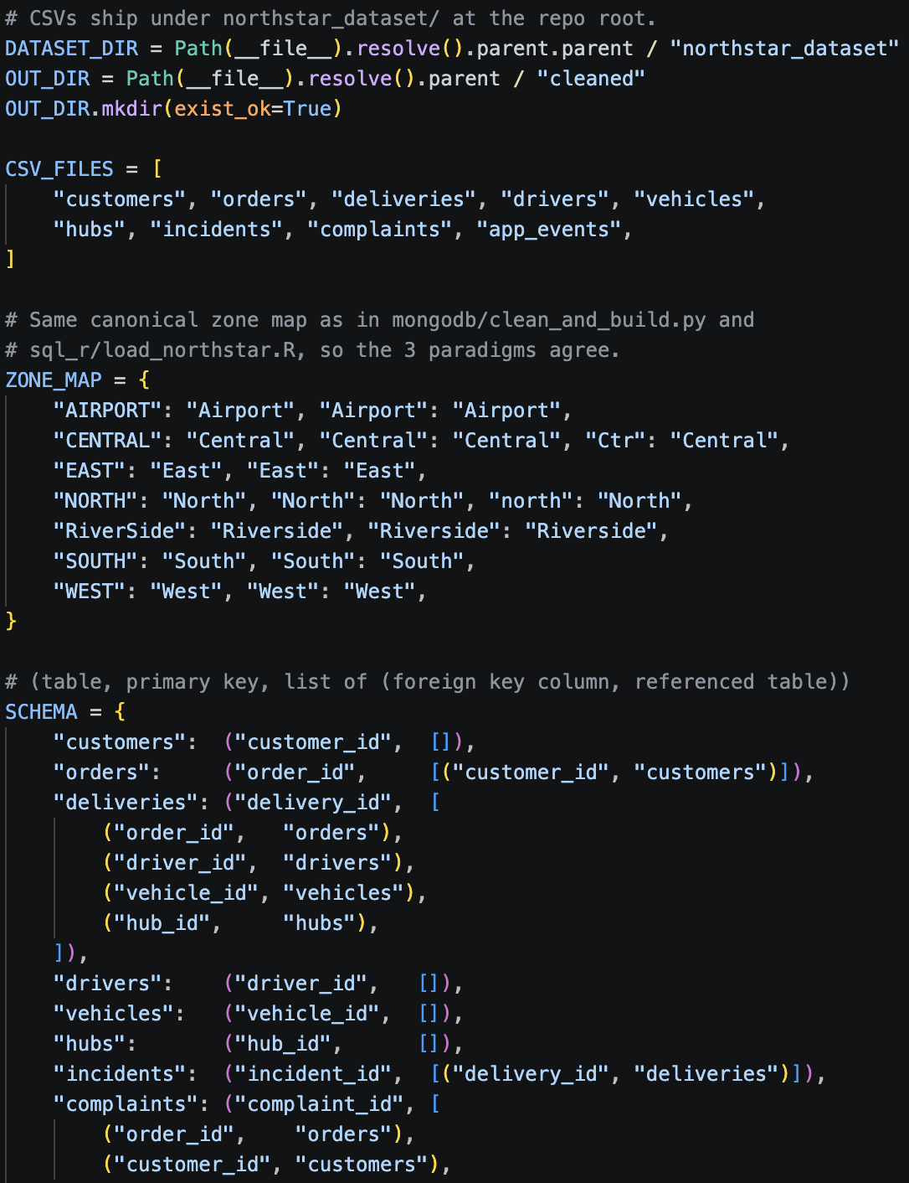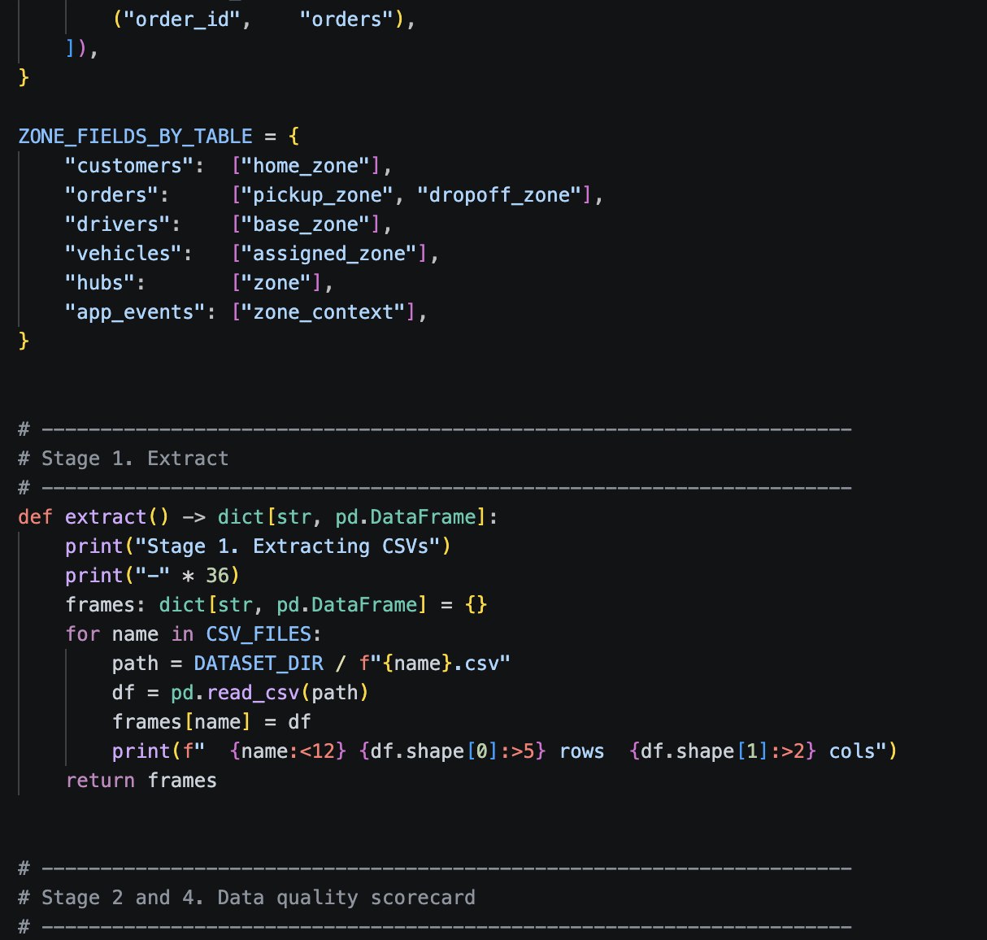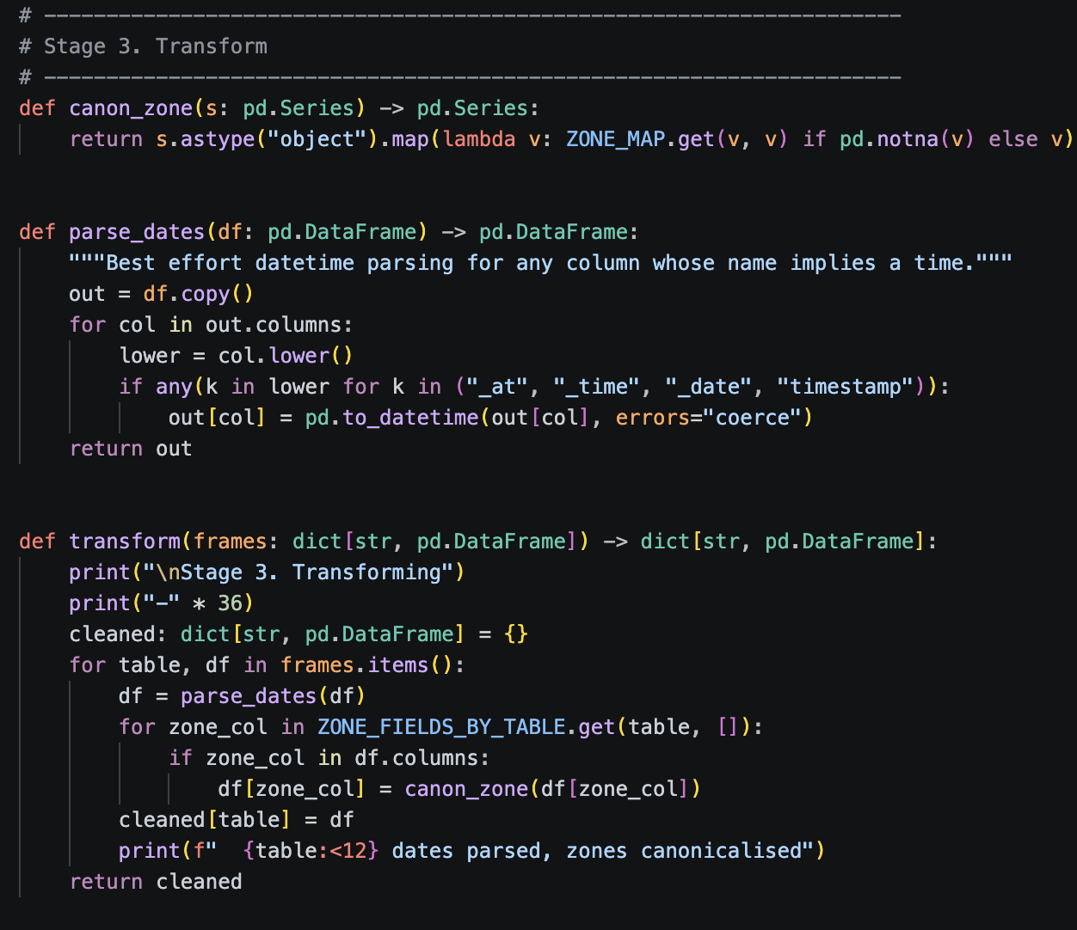Listing 15: Dataset_Dir, Zone_Map, Extract + Canon_Zone
6.2 5-dimension data quality scorecard
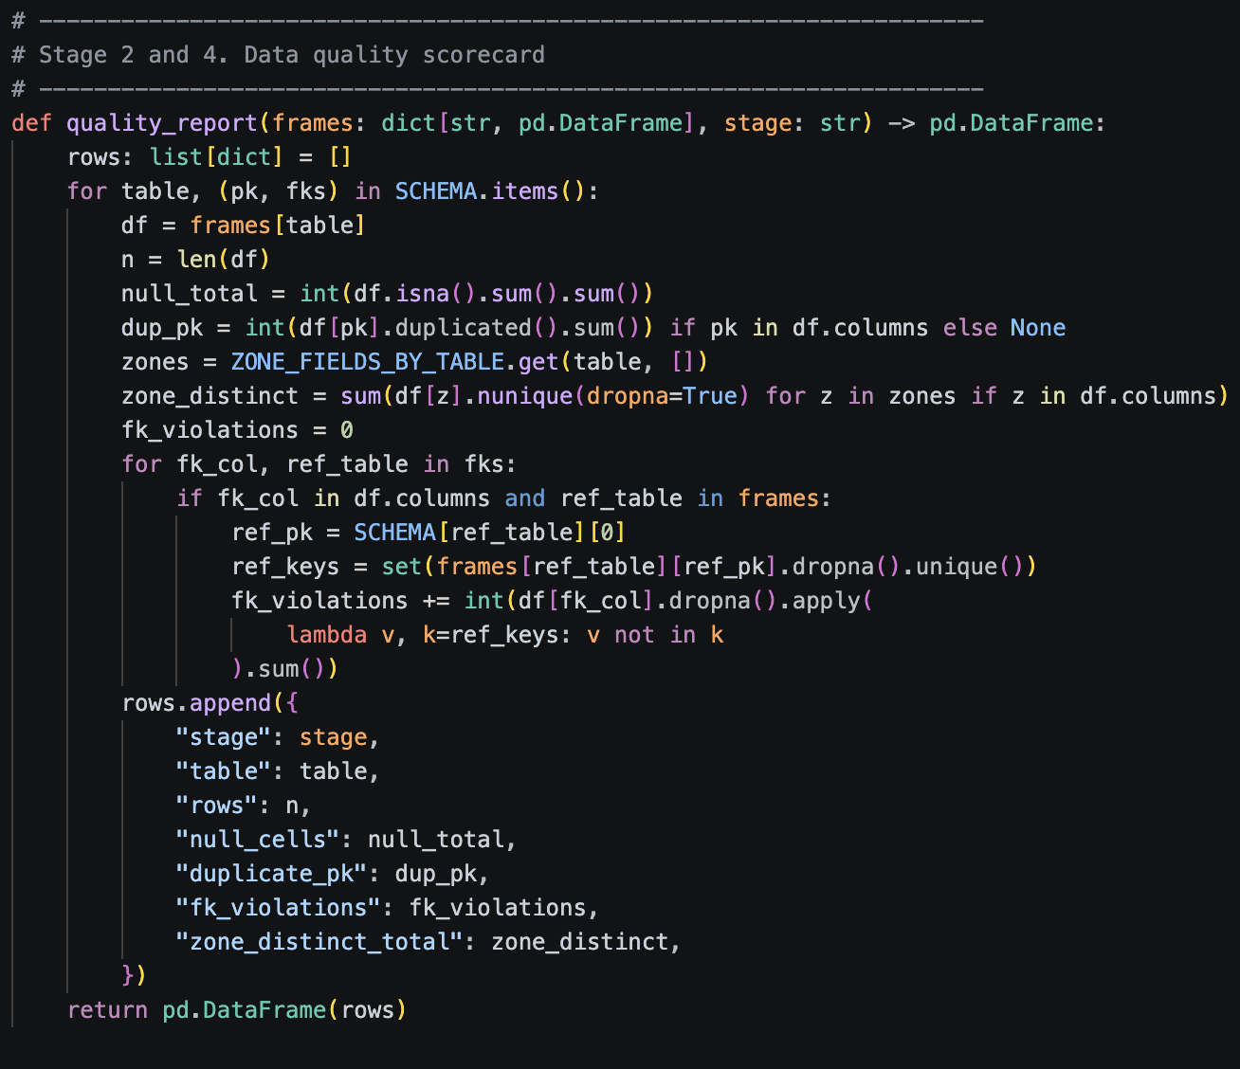Listing 16: Quality_Report Function
5 dimensions: rows, total NA cells, duplicate PKs, FK violations, distinct zone count. Runs once before cleanup and once after. The cleanup is deliberately non-destructive: no imputation, no row drops, only string canonicalisation and date parsing.
6.3 scipy chi square
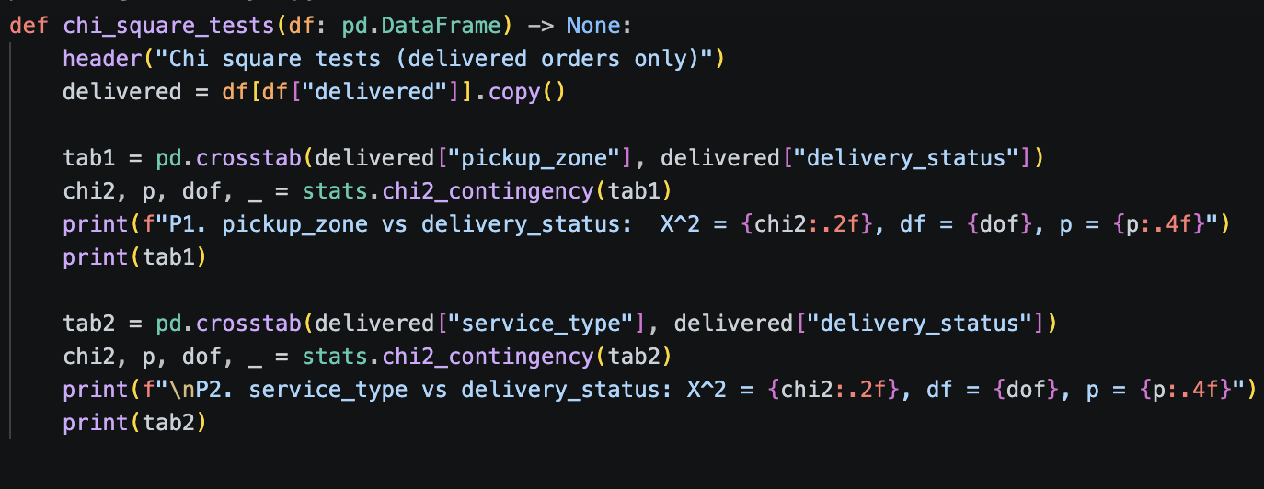Listing 17: Chi_Square_Tests: 2 Tests Mirroring The R Analysis
6.4 scikit-learn random forest
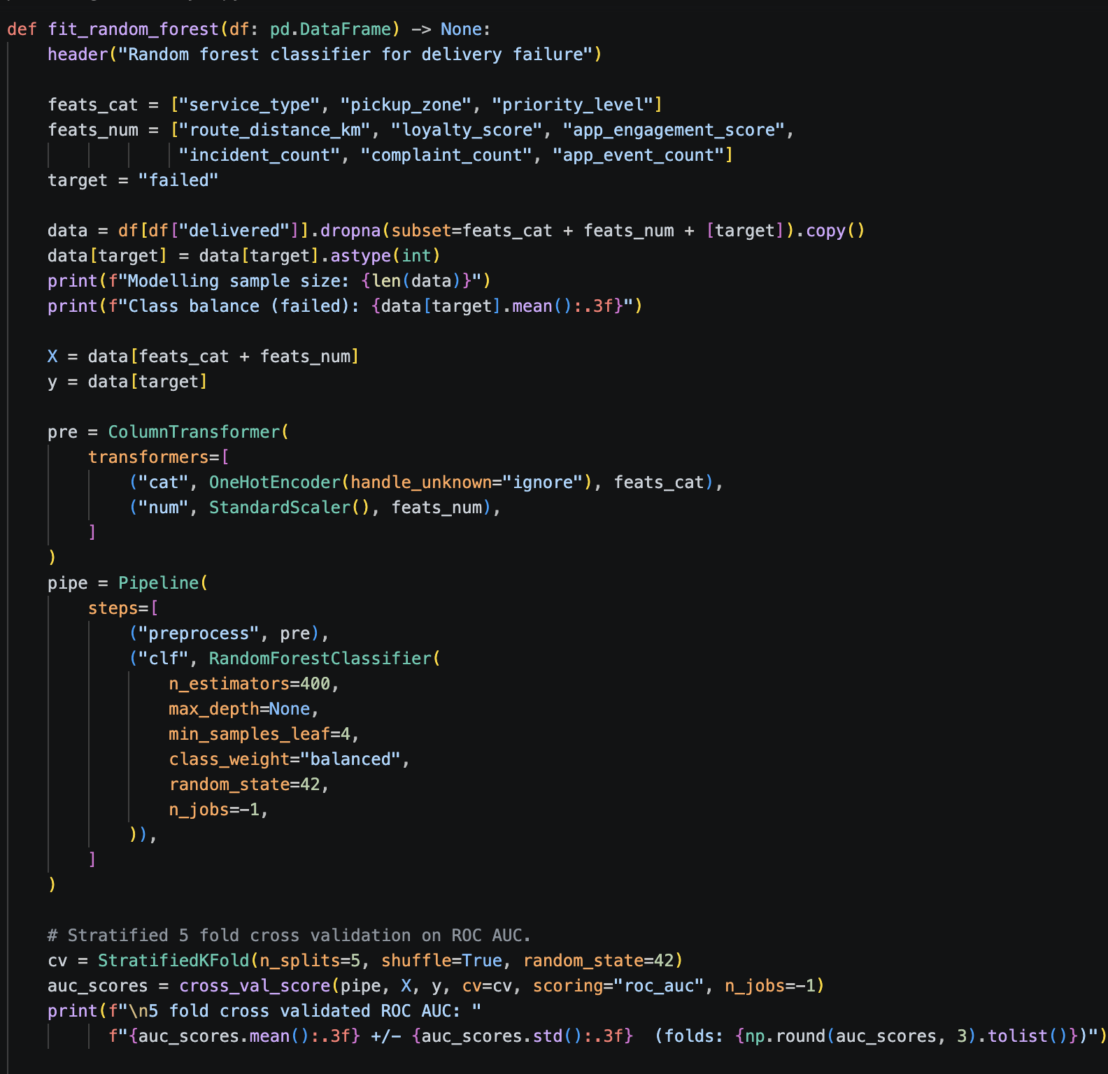Listing 18: Fit_Random_Forest: Pipeline + Stratified 5-Fold Cross-Validation
Random forest specifically because it handles mixed feature types without manual preparation and captures non-linear interactions that the R linear logistic regression cannot. If both find no signal, the signal is not at order level. 5-fold ROC AUC: 0.487 +/- 0.064.
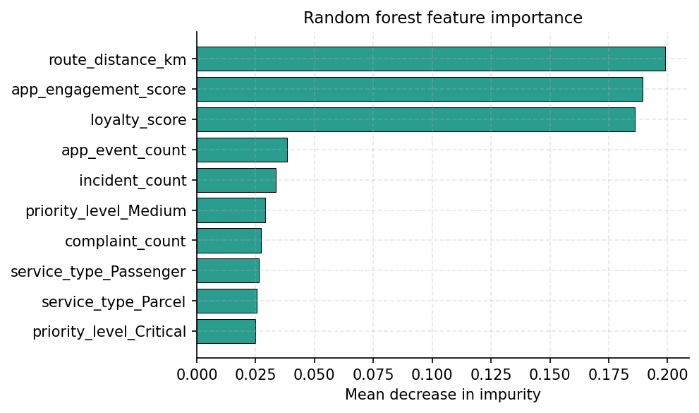
Figure 6: Random Forest Feature Importance
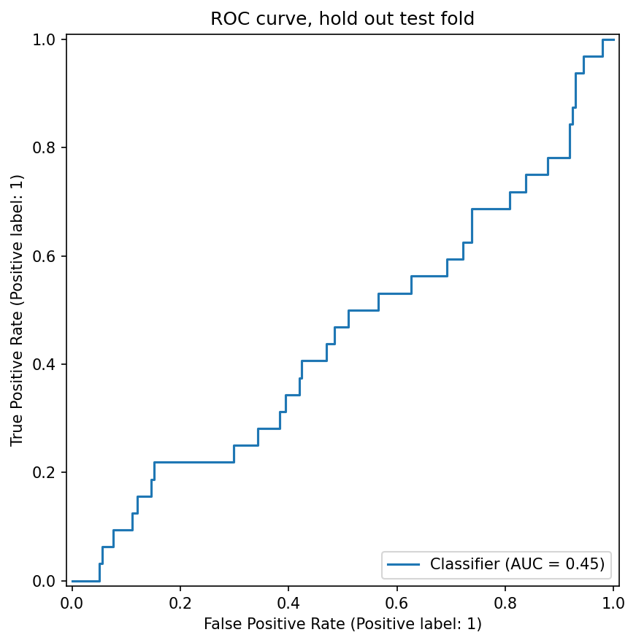
Figure 7: ROC Curve on the Hold-Out Test Fold
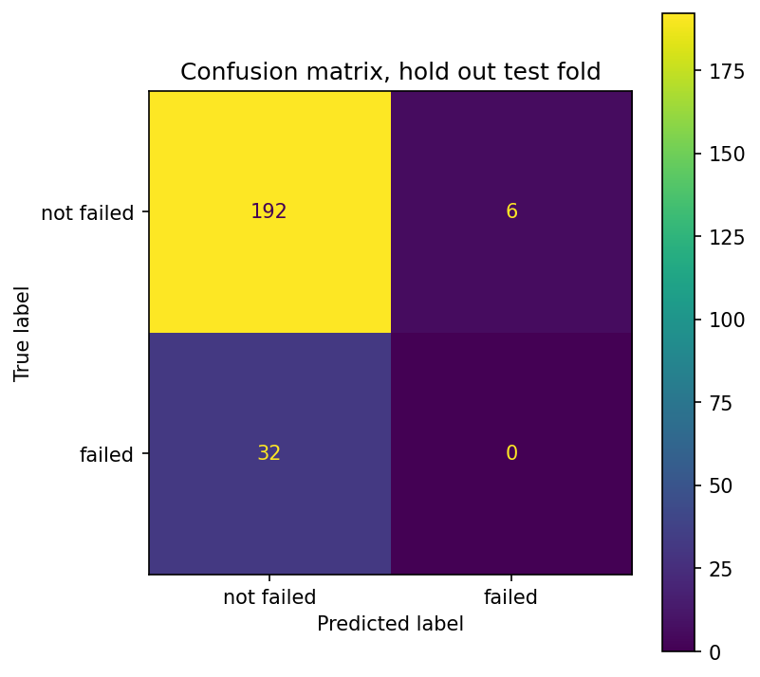
Figure 8: Confusion Matrix on the Hold-Out Test Fold

TABLE | ROWS | NULLS | DUP PK | FK VIOLATIONS | DISTINCT ZONES
customers | 650 | 0 | 0 | 0 | 11 to 7
orders | 1250 | 0 | 0 | 0 | 32 to 14
deliveries | 950 | 0 | 0 | 0 | n/a
drivers | 170 | 0 | 0 | 0 | 11 to 7
vehicles | 120 | 0 | 0 | 0 | 11 to 7
hubs | 8 | 0 | 0 | 0 | 11 to 7
incidents | 280 | 0 | 0 | 0 | n/a
complaints | 320 | 0 | 0 | 0 | n/a
app_events | 640 | 0 | 0 | 0 | 16 to 7
Figure 9: Data Quality Scorecard, Post-Cleanup State
7. Critical Reflection
Limitations. The dataset is small (1,250 orders, 132 failures), so the chi-square is a population-level summary rather than a per-cell verdict; standardised residuals would identify the specific cells driving the rejection. I did not apply Bonferroni correction across the 4 hypothesis tests, which inflates the family-wise error rate to about 18.5%; the p of 0.0103 is robust but should be replicated on more data. The random forest uses mean decrease in impurity, biased toward continuous and high-cardinality features; permutation importance is the more rigorous alternative.
Methodology. Running the same business questions through 4 paradigms is a check that no single-implementation project can offer. When MongoDB's $group, SQL's GROUP BY, R's dplyr and pandas's groupby return the same numbers, every join and cleanup step is independently validated. The chi-square test on the pickup zone agrees between R and scipy to 4 decimal places; this is the strongest evidence that the contingency table is correct in both pipelines.
Next steps. First, denormalise driver attributes onto orders_aggregate so the $lookup is removed from the analytical workload (the join is the most expensive operation I run). Second, gather external features that the dataset never sees, such as the weather, road closures, and real-time traffic, and rerun the random forest with them; the null result is almost certainly because the predictive signal lies outside the operational data, not within it. Third, drill into the chi-square residuals to turn the population finding into a per-zone-by-service shopping list.
8. Conclusion
4 paradigms, 1 dataset, 1 conclusion. The order-level predictive signal is absent: a random forest with 9 candidate predictors cannot outperform random guessing (AUC 0.487). The population-level signal is real: a chi-square test on the pickup zone is significant (p = 0.0103), and the descriptive heatmap shows Central and North as the elevated-failure zones. The operational recommendation for NorthStar follows from the data, not from intuition: target the failing zones, not the failing orders.

